

Handout no. 10

|  |  |
| --- | --- |
| **Name** | Muhammad Asad |
| **Reg. No** | 2019-EE-383 |
| **Marks/Grade** |  |

**EXPERIMENT # 10**

Differential Protection for Power Transformer

**Objective:l**

At the end of this lab session students will be able tol

* Understand the working of Differential Relay.
* Model Differential relay in Matlab Simulink.

**Differential protection:**

Differential protection, as its name implies, compares currents entering and leaving the protected zone. It operates when the differential current between these currents exceed a predetermined level. In this protection scheme faults are detected by comparing the currents flowing into and out of the protected object.

Current based differential protection is applied in power system to protect the power transformers and bus bars. The differential scheme which is used to protect the transformer is called the current balance or circulating current scheme. It is based on ampere-turn balancing of all the windings mounted on the same magnetic core limb.

**Laboratory Task:**

Implement a Differential-Relay that protects the Power-Transformer against all the faults within the protected zone. Protected zone is the region between two current-transformers on either sides of Power-Transformer. Relay should not operate for the faults outside the protected zone.

**Procedure:**

# Step 1:

Draw a power system having a three phase source, three phase circuit breakers, three-phase

VI measurement units, three phase transformer (two winding) and three phase RLC series load. Connect the blocks as shown in figure and set the parameters as specified.

.



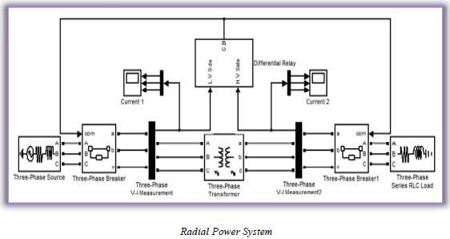

ln above figure, two inputs ‘L.V Side’ and ‘H.V Side’ of ‘Differential Relay’ are currents from low voltage side and high voltage side of transformer respectively.

l.

Slet the properties of each block as mentioned below. Keep all other parameters as it is. l

Slystem Frequency: 50 Hz Tlotal Simulation Time: 0.5 s

S.lolver: Ode23tb (stiff/TR-BDF2)

Sollver reset Method: Robust

# Three phase source:

Voltage (Phase to Phase): 11e3 V lnternal connection: Y grounded 3l. phase short circuit level: 500e6 VA B.ase voltage: 11e3 V

# Three-Phase Breakers:

Initial status of breakers: closed

# Three-Phase Transformer (Two Windings):

Winding 1 connection (ABC terminals): Y grounded Winding 2 connections (abc terminals): Y grounded Nominal power and frequency: [200e6, 50]

Winding 1 voltage: 11e3

Winding 2 voltage: 33e3

Magnetization resistance Rm: 1e6

Magnetization inductance Lm: 1e6

# Three-Phase Series RLC Load:

Configuration: Y grounded

Nominal voltage: 33e3 V

Active Power (MW): 150e6 W

Inductive reactive power: 50e6 VAR

Capacitive reactive Power: 0 VAR



# Step 2:

In subsystem “Differential Relay”, connect the blocks as shown in the diagram and set the

parameters of blocks as specified.

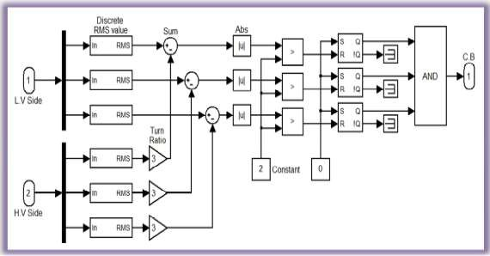

**Discrete RMS value:** *(SimPowerSystems >> Extra Library >> Discrete Measurements)*

Fundamental frequency (Hz): 50

**Gain (Turn Ratio):** *(Simulink >> Commonly Used Block)*

Gain: 3

**Sum:** *(Simulink >> Commonly Used Block)*

List of signs: |+-

**Abs:** *(Simulink >> Math Operations)*

**S-R Flip-Flop:** *(Simulink Extras >> Flip Flops)*

Initial condition: 1

Run the simulation and observe output on both scopes.

# Step 3:

Now connect three *three-phase fault* blocks as shown in figure and set their parameters as specified.

# Three-Phase Fault (Fault 1, Fault 2, Fault 3):

Ground fault: Select this option External control of fault timing: Select this option Initial status of fault: [0 0 0]

**Timer 1:** *(SimPowerSystems >> Extra Library >> Control Blocks)*

Time (s): [0 0.08 0.14]

Amplitude: [0 1 0]



|  |  |
| --- | --- |
| **Timer 2:**  Time (s): | [0 0.35 0.42] |
| Amplitude: | [0 1 0] |
| **Timer 3:**  Time (s): | [0 0.2 0.26] |
| Amplitude: | [0 1 0] |

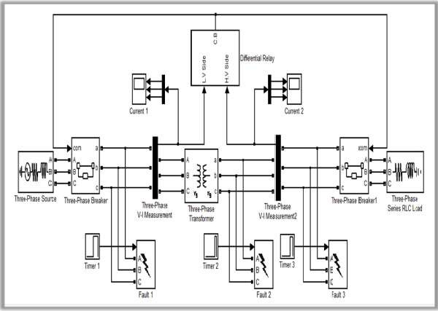

Run the simulation and observe the waveforms of current on both scopes.

In above figure *Fault 1* and *Fault 3* are outside the protected zone of Differential relay so relay does not trip. But *Fault 2* occurs inside the protected zone so relay picks the fault and opens the circuit breakers to clear it.

**Note**: If the simulation is taking a long time to complete, change the “powergui” setting from “continuous” to “Discrete” and set sample time *50e-6*. The “powergui” block is present on the top left corner of your main Simulink file. If powergui block is not present in the file, place it from SimPowerSystems toolbox.



Now implement same relay in which comparison should be done between sinusoidal currents

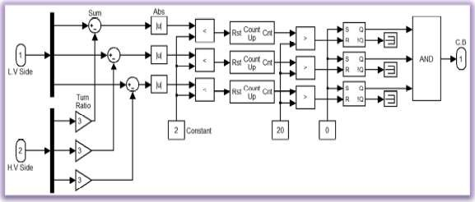

instead of their RMS values. In the differential relay block make changes as shown below.

In above logic of differential relay RMS blocks have been removed and a delay of 20ms has been introduced by using counter. These counters are in their free running state and their counting rate is 1000 counts per second. To insert this delay ‘relational operators’ prior to the counter blocks have been changed from ‘>’ to ‘<’.

Run the simulation after these changes. You will observe that relay trips the circuit breaker initially. This is due to the phase difference between two currents. The both primary and secondary currents are 180 out of phase due to the connection of second CT (Three-Phase V-I Measurement2).

Reverse its connection as shown below to make the both currents in phase.

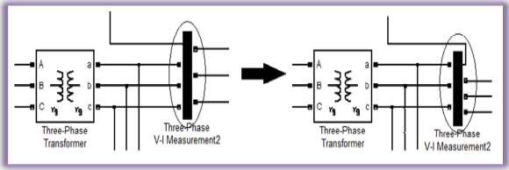



# Assignment: (10 Marks)

* Implement a “Differential Relay” that protects the YΔ power transformer having any one of the following vector groups.
  1. Dy1
  2. Dy11
  3. Yd1
  4. Yd11
* Relay must have following inputs
  1. Primary current
  2. Secondary current
  3. Turn ratio
  4. Reset
* Energize the system after the tripping of the circuit breaker through reset.
* Attach printout of Simulink model, output on the both scopes (current only), comprehensive details of modifications and the settings of the blocks (computer typed). Values of all the constant blocks and gain must be clear in the snapshot of model.
* Assignment should be complete in all respects.
* Bring the assignment in next lab session.

**MATLAB Differential Relay Circuit:**

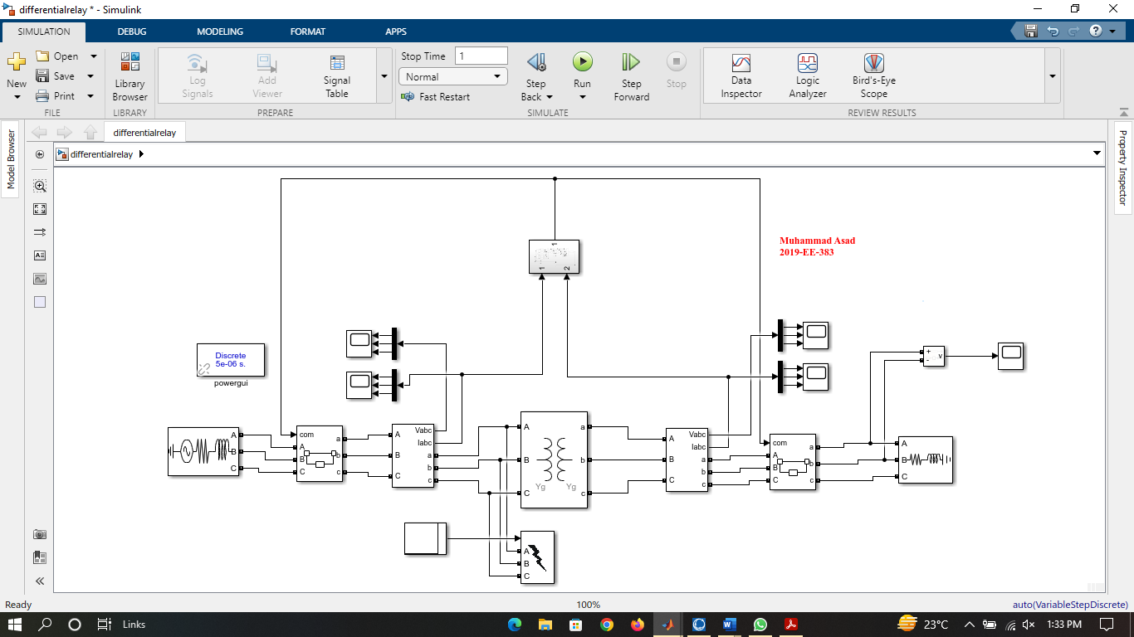



**Subsystem Circuit:**

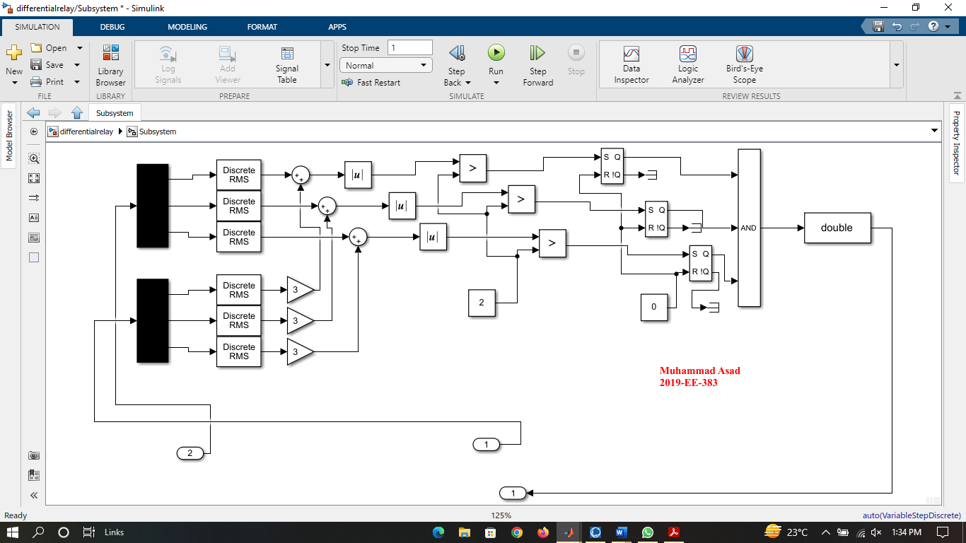

**Component Parameters Pictures:**

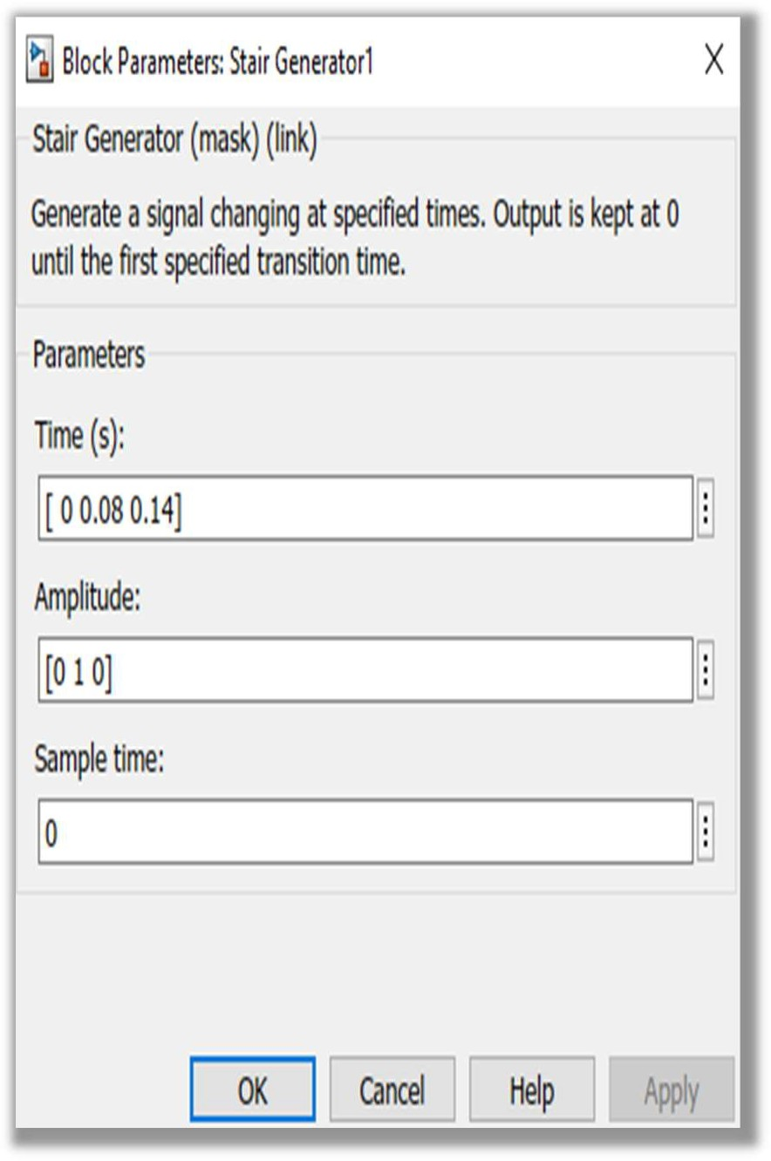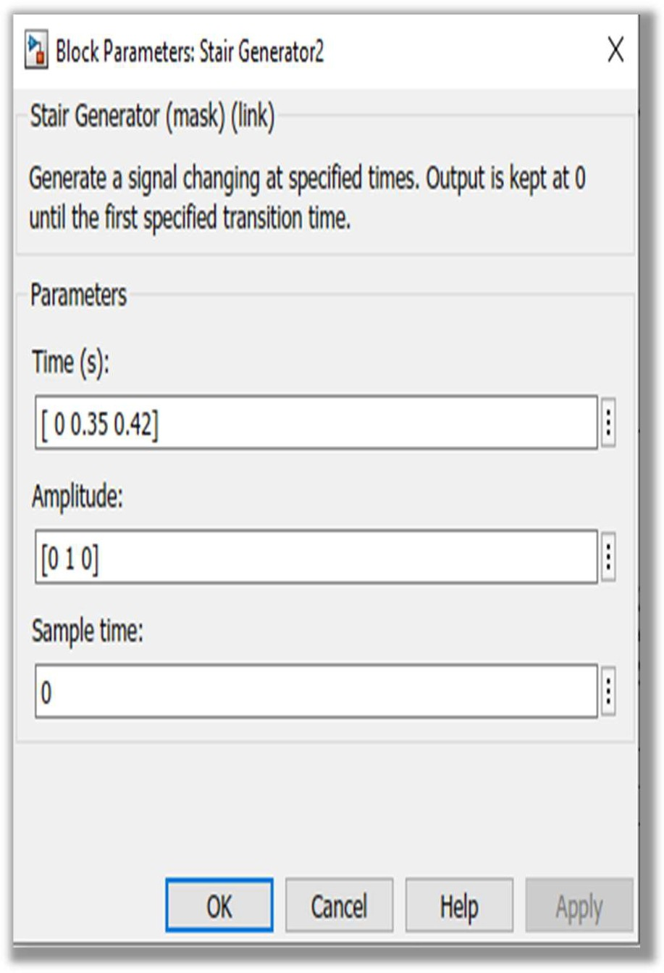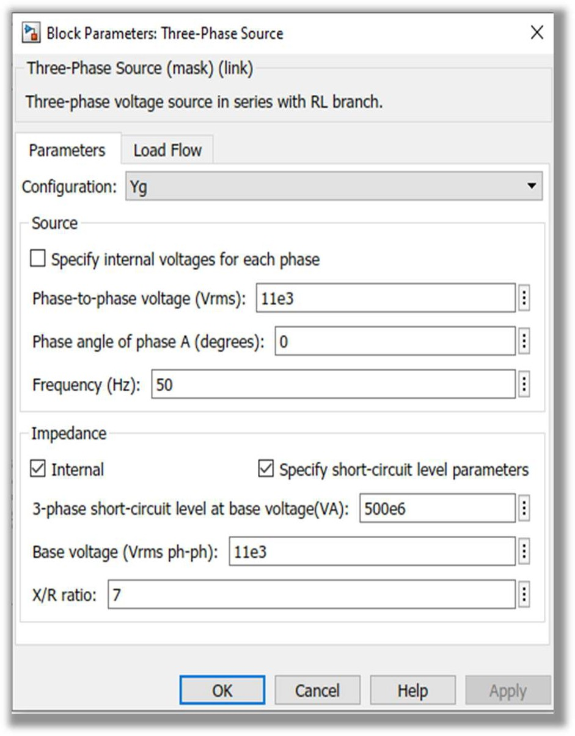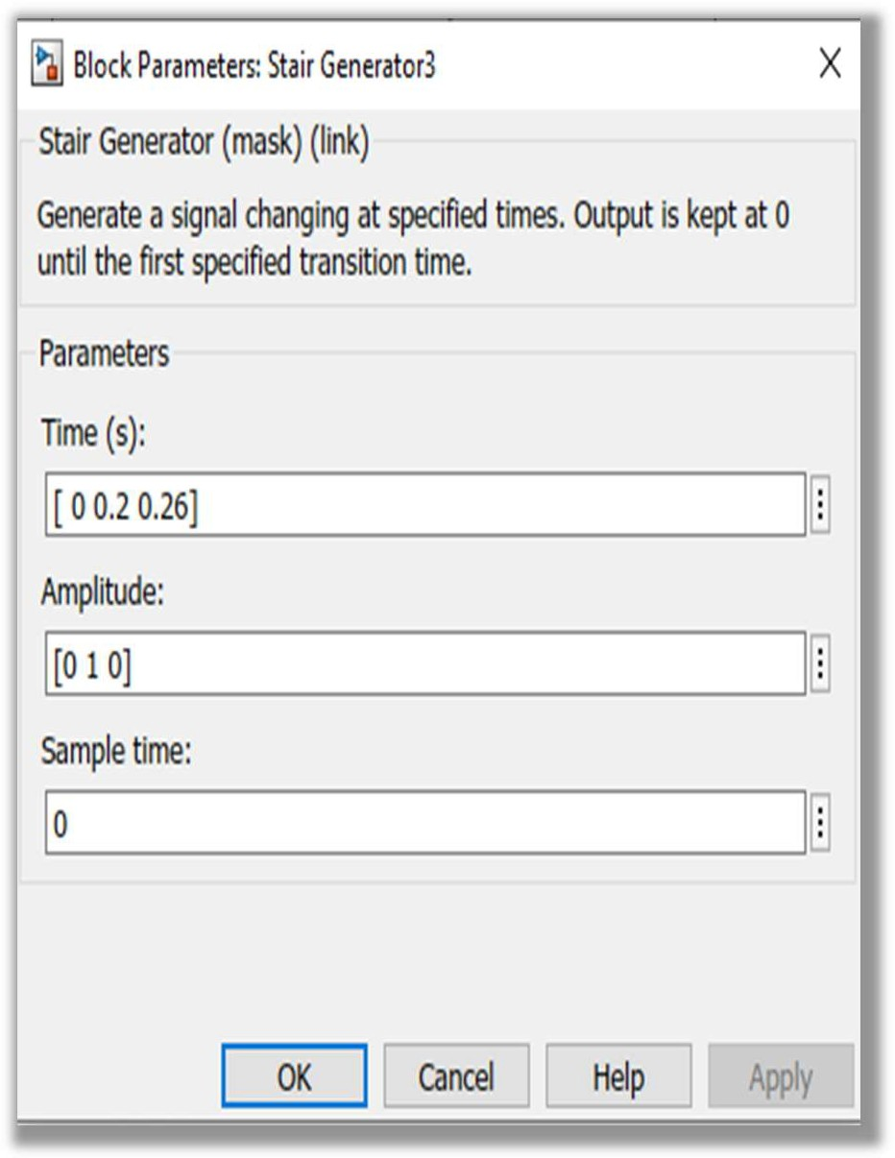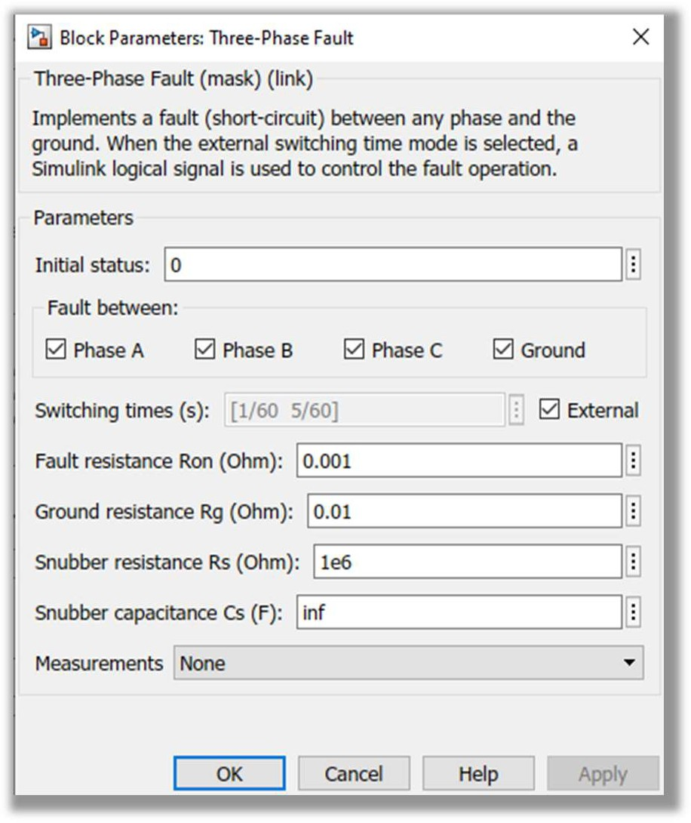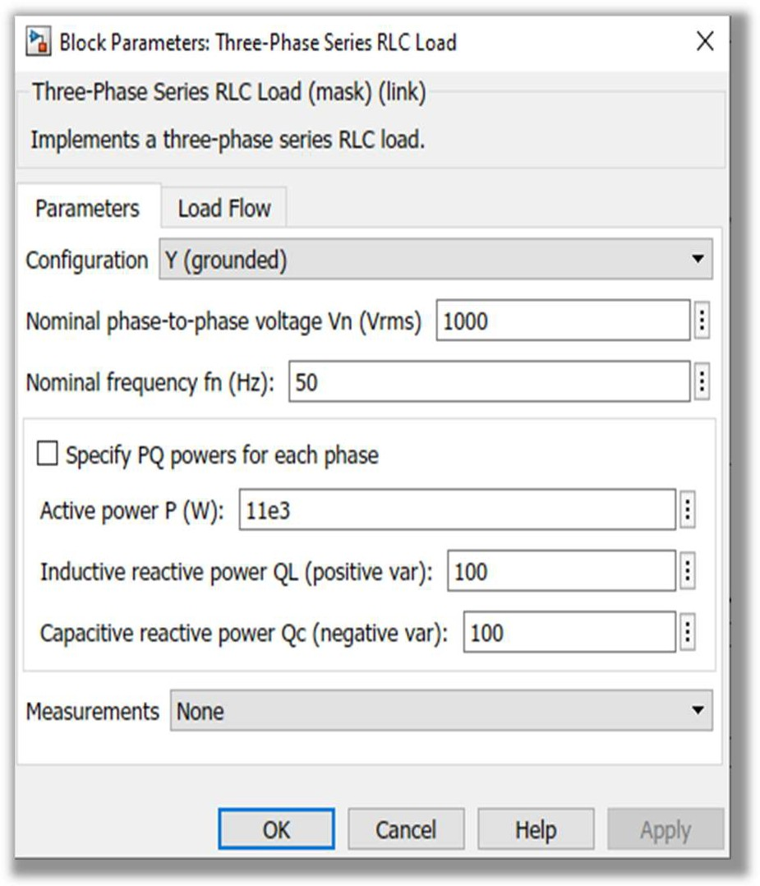

**Before Fault Output:**

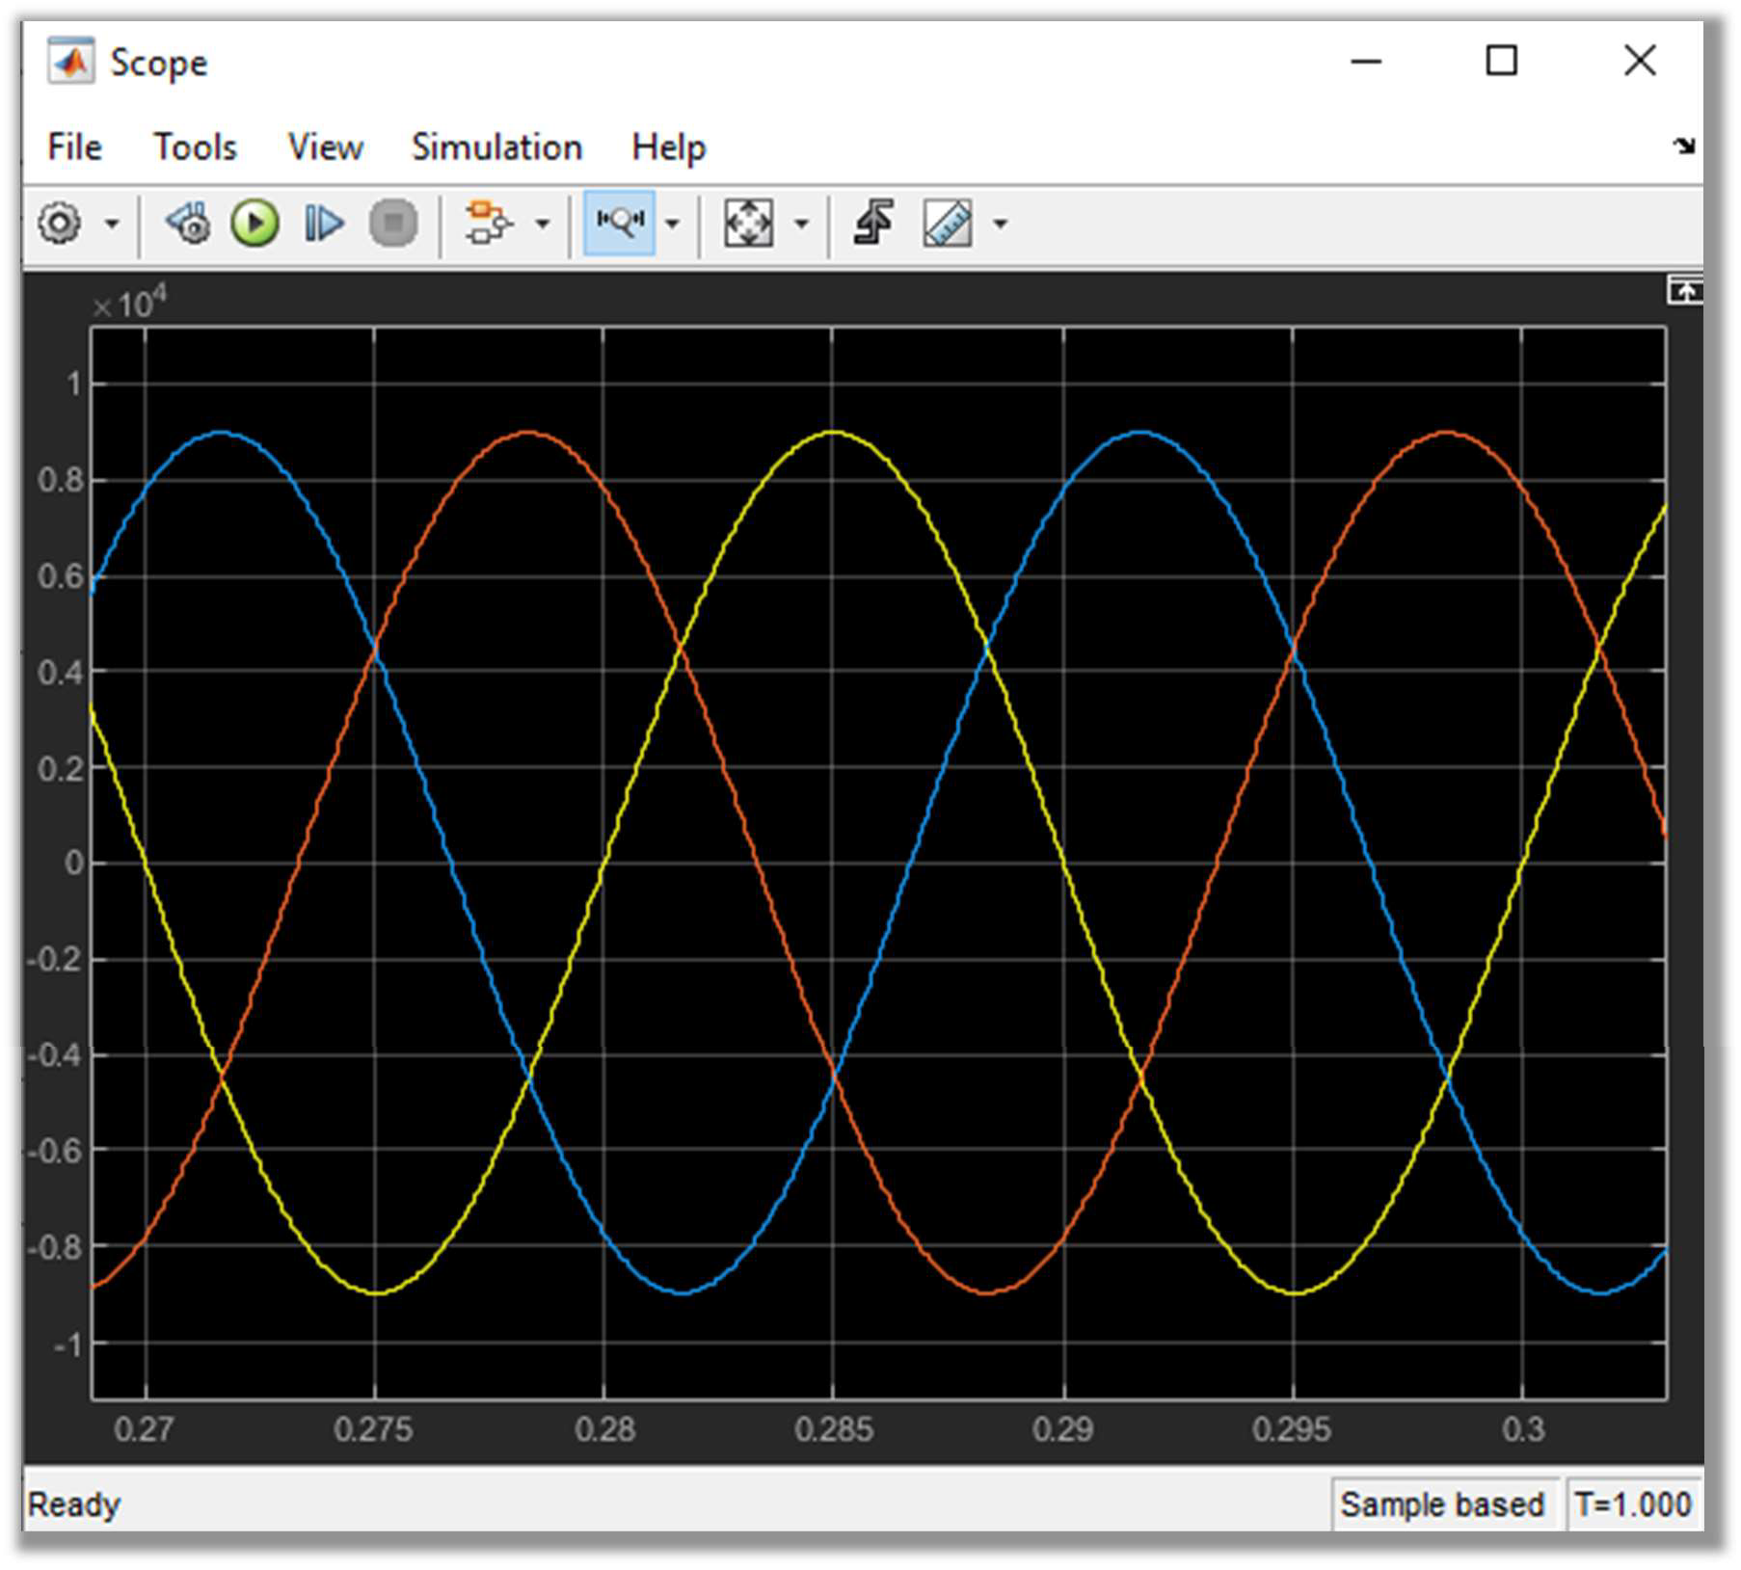

**After Fault Output:**

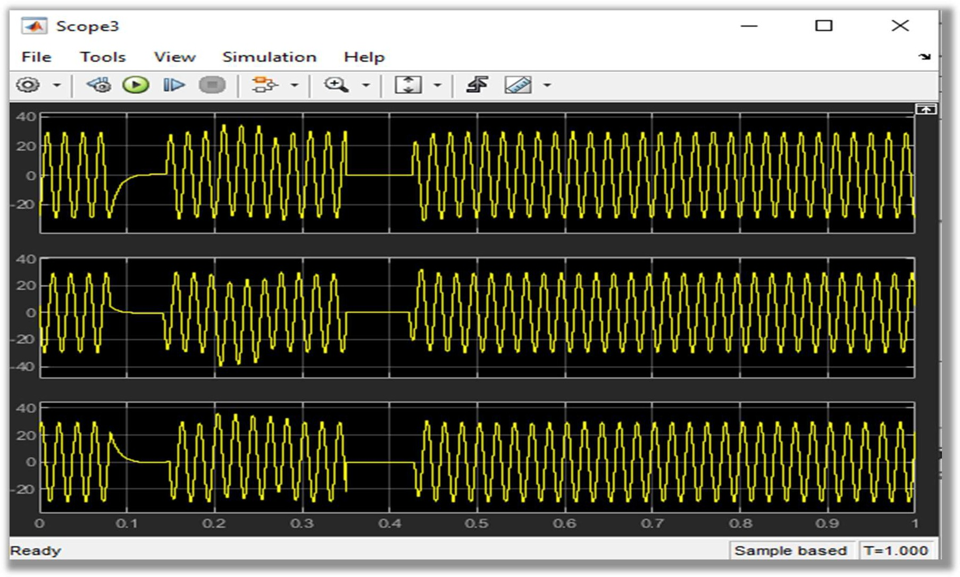

**Load Side Output(V & I):**

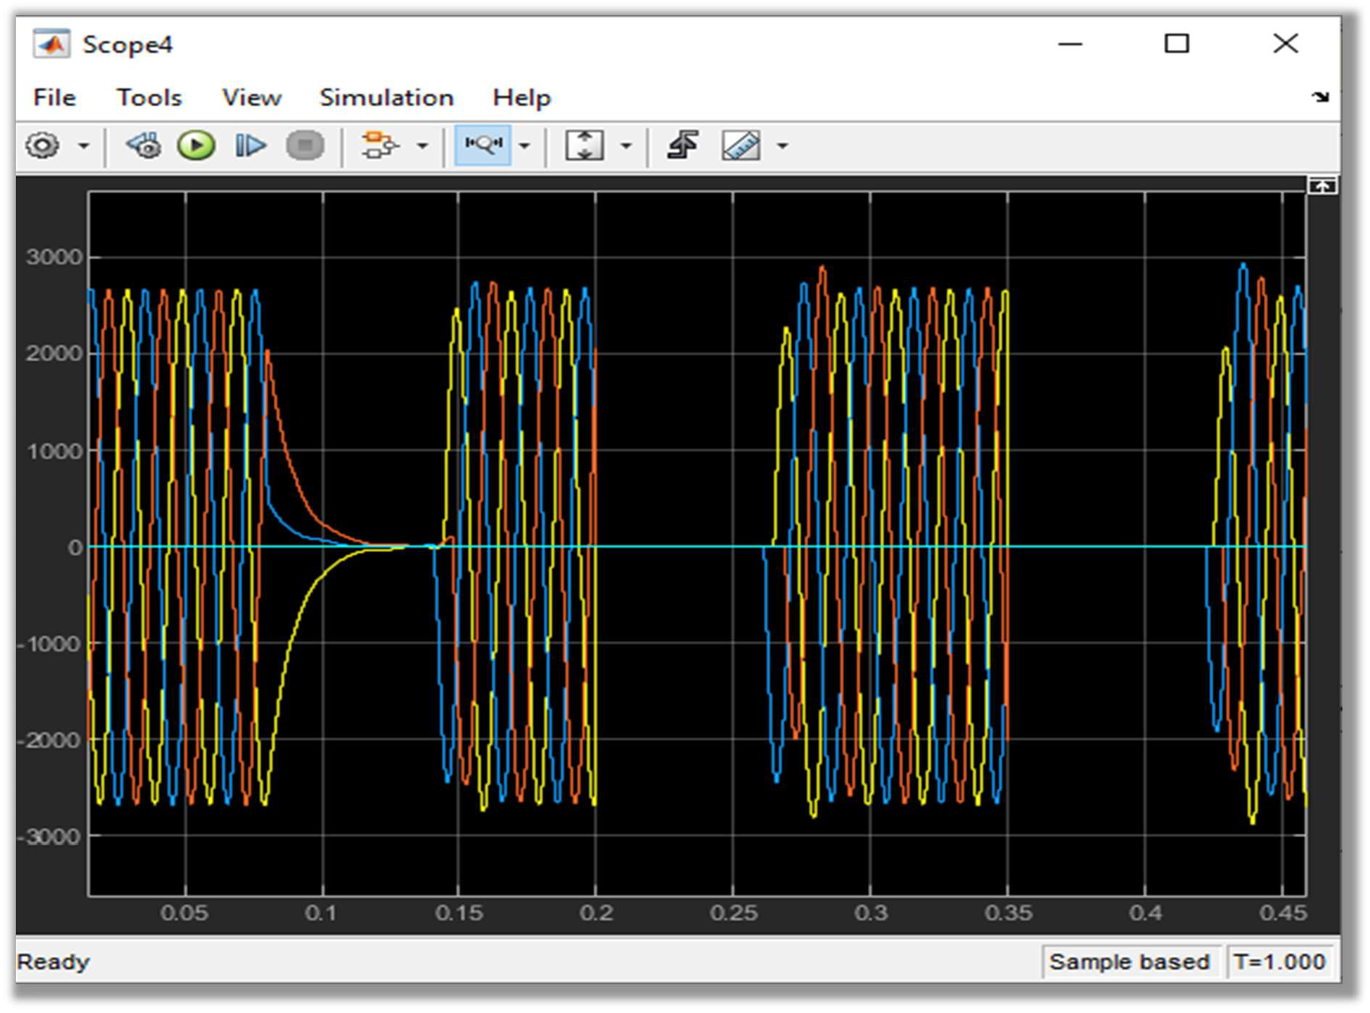

**Conclusion:**

In this lab, we learn about the design and implementation of differential relay by using MATLAB (Simulink). First of all, we design the power system model for that we have to operate differential relay. Then we define the zone of protection for differential relay. After that, we inserted the fault inside and outside the zone. We conclude that:

➢ When fault is inserted inside the zone of protection of differential relay. Current rises to maximum value. Relay detects this fault (as shown in graph of relay signal) when current cross the threshold or pickup value which is 1000A we set. Differential Relay compare the fault current value with pickup value. If this difference is above the set value differential relay sends tripping signal to breaker and break the line in 0.1sec So, 0.1sec is the operating time of relay.

➢ When fault inserted outside the zone of protection of differential relay for 0.05sec to 0.1sec as shown in above waveform. Relay didn’t detect this fault as it is outside the zone of protection and remain open in this fault condition.

We conclude that if use differential relay for protection of equipment. It can precisely detect the fault in its own zone of protection and can’t detect the fault which is outside the zone. So, there is no chances for the loss of security because this relay operates only in its own zone of protection.